Arsalaan Ansari (aaa2325)

**HW 5**

1a)

Top 25 rankings for iterations 10, 100, 1000, 10000

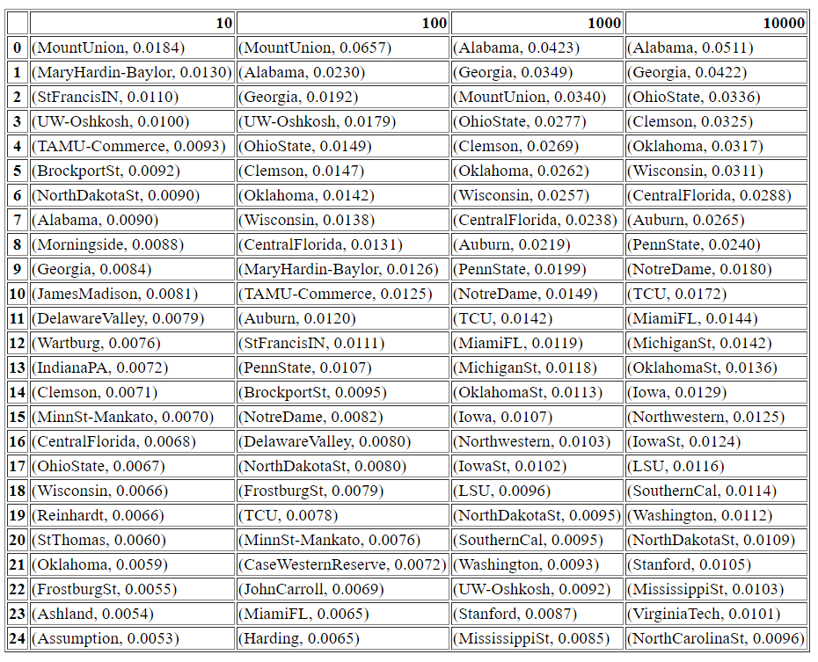

1b)

Plot of $\left\|w_{t}-w_{∞}\right\|$ vs t

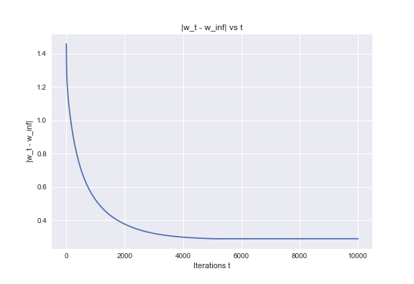

2a)

Plot of objective functions vs iteration t

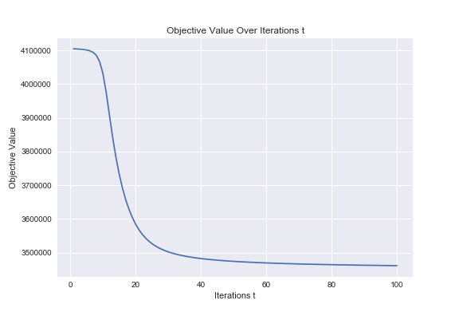

2b)

Table of topics and weights for top ten words in specific topic

